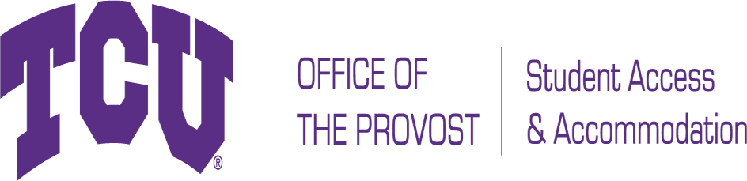

# TCU Box 297008, Fort Worth, Texas 76129 [studentaccommodation@tcu.edu](mailto:studentaccommodation@tcu.edu)

**Phone: 817-257-6567 Fax: 817-257-5358** [**www.tcu.edu/access-accommodation**](http://www.tcu.edu/access-accommodation)

Documentation Guidelines for Blind and Low Vision

In order for Student Access and Accommodation (SAA) to evaluate requests for accommodations and/ or auxiliary aids and to determine eligibility for services, appropriate disability related documentation is needed. The documentation submitted should include an evaluation by an appropriately licensed professional and should demonstrate the current impact of the disability as it relates to the accommodations requested. The documentation should also include a description of any and all relevant functional limitations.

Legal blindness: In the better eye, (1) visual acuity 20/200 or less with correction, or (2) a visual field limitation such that the widest part of the visual field covers an angle no greater than 20 degrees. Low vision: Severe visual impairment that typically is partially improved, but not fully resolved, by corrective lenses.

**A qualified professional must conduct the evaluation.**

Professionals conducting assessments, rendering diagnoses, and offering clinical judgments must be qualified to do so. It is essential that professional’s qualifications include both (1) comprehensive training and relevant experience in the specialty with an adolescent and young adult population; and (2) appropriate licensure/certification. For most individuals who are blind or have low vision, the evaluation should be performed by a doctor of ophthalmology or optometry. The name, title, and credentials of the qualified professional writing the report should be included. Information about licensure or certification, including the area of specialization, employment and the state or province in which the individual practices, should also be clearly stated in the documentation. The documentation must be in a typewritten report on professional letterhead that bears the evaluator’s name, license number, professional credentials, business location, contact information and signature.

# Testing Should Be Current.

Because of the changing manifestations of many visual conditions, it is essential that the student provide recent and appropriate documentation from the optometrist or ophthalmologist. If the diagnostic report is more than three years old, the student must submit a letter from a qualified professional that provides an update of the diagnosis, an indication of the severity of the academic functional impact of the disability and a rationale for each of the requested accommodations in both academic and residential settings. The nature, severity, and extent of the student's condition and the functional limitations as they relate to a postsecondary environment should be addressed. Typically, the recommendations cannot be supported

solely by a history of prior accommodations or self-report. In some cases, an updated letter from a qualified professional may simply address why older documents or reports continue to be relevant.

# Documentation to support the diagnosis should be comprehensive.

**Specific diagnosis**. Qualified professionals are encouraged to cite the specific objective measures used to help substantiate differential diagnoses. The evaluator should use definitive language in the diagnosis of a visual condition, avoiding such speculative language as "suggests," "is consistent with," or "could have problems with."

**Description of current functional limitations**. This would include daily life activities in academics and housing with the understanding that a disability usually presents itself across a variety of settings.

**History**. This would include a history of presenting symptoms, date of onset, duration and severity of the disorder, and whether the disorder is stable, progressive or degenerative.

**Current medical information**. This would include relevant developmental, medical, and historical data about the condition and how the current functional limitations restrict the condition, manner, or duration of the student’s performance of major life activities.

# Relevant Disability Specific Information.

1. Best corrected visual acuities for distance and near vision;
2. Eye health;
3. Visual fields;
4. Clinical observations;
5. Binocular evaluation: whether the applicant experiences difficulty with distance, near-point, or both;
6. Accommodative skills: at near point, with and without lenses;
7. Oculomotor skills: saccades, pursuits, tracking;
8. Academic and residential functional impact: How do the points summarized above, in combination, impact the student in academic and residential functioning? For example, is it likely that the student will experience double vision? Headache? Visual fatigue? Will the student benefit from more time WITH a test, or more break time AWAY from a test, or both, or neither? Is the functional impact likely to be different with a print test than with a test taken on computer? If so, why and how?

Student Access and Accommodation will make the final determination as to whether appropriate and reasonable accommodations are warranted and can be provided to the individual. All documentation submitted to SAA is considered to be confidential under FERPA guidelines and as outlined by University policy.